**Error handling in the UI**

The error handling that takes place in our project is more like error prevention. We try to guide the user by restriction to act as we expect him to act living him/her with less options to input false data. For example here (picture 5)

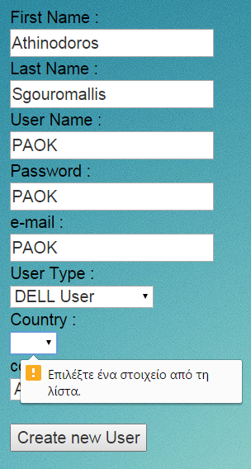All the fields that have to be filled are marked   
as mandatory in the code.

Fields That take only specific values are   
dropdown lists.

Although no methods where made to check  
 them further for example if an password is   
more than 8 characters |with mixed symbols,  
 capital and lower case letters

(picture 5: create user Form)